WSL2 Setup on Windows with Ubuntu 24.04.1 LTS Using TAR file

NOTE: From a software licensing perspective, the only approved Propello developer applications are Windows11/WSL-Ubuntu, PyCharm, Postman (free addition NOT logging into an account) and DBeaver community edition. Any other software you install MUST be approved by Chris Vickery.

1. Enable WSL2 and Virtual Machine Platform
Run the following command in Command Prompt (run as Admin):
dism.exe /online /enable-feature /featurename:VirtualMachinePlatform /all /norestart
Then, install WSL2:
wsl --install
wsl --update # Run repeatedly until no more updates are found
Option 2) Graphical way
- Search `Turn windows features on or off` on windows search bar.
- Enable `Virtual Machine Platform` and `Windows Subsystem for linux`.
- Reboot the PC.
Extra steps to check wsl:
PS C:\> wsl --status
Output:
Default Distribution: ERC
Default Version: 2
Note: If Version is not shown, then do `wsl --install` and `wsl –update`

2. Configure WSL Networking
Create a .wslconfig file in your Windows home directory (C:\Users\yourusername) and add:
[wsl2]
networkingMode=mirrored
[Note :Above step could be done using powershell “PS C:\WINDOWS\system32> New-Item C:\Users\< yourusername >\.wslconfig” and then edit this file using notepad]
Restart WSL. Return to your Powershell prompt and run
wsl -–shutdown
wsl

3. OpenVPN Installation for Windows
- Install the newest version of OpenVPN Client, NOT OpenVPN Connect. Check Community Downloads - Open Source VPN | OpenVPN for the latest release.
- Find your VPN profile and use your credentials (you should have received this for your original dev env) << TBD – who is the contact for getting profile info if unknown >>
- Right click on the system tray icon, import your OpenVPN Profile, and connect to OpenVPN

4. Download and Import TAR File
- Tar file is located in Teams/Epicor Retail Cloud Development/General/Files/temp/Proenv.tar Link: PROenv.tar
- Copy the TAR file somewhere on your PC in a Windows folder (like c:\holdvm)
- Import the tar file from a Windows command prompt (as Admin)
- wsl --import ERC .\erc PROenv.tar --version 2

5. Cleanup Terminal Window
Go to terminal settings and change the default profile to Ubuntu-24.04
In your terminal window, update settings/startup to have default profile set to Ubuntu-24.04
Click the down arrow next to “+”, choose settings/startup/default profile
Unregister any spawned, extraneous wsl instances
wsl – list
wsl –unregister <ubuntu or ubuntu-xxx> for any in list that are not Ubuntu-24.04
Start wsl, get shell access
Either search for wsl in Windows search bar or run wsl from a Windows command prompt
Note – username = ubuntu, password = ubuntu

Extra Notes:
- run wsl on the power shell
- The possibility is it’ll open in the root mode, switch it to `ubuntu` user. (Note: For a default Ubuntu installation under WSL, the default uid (typically 1000) is stored in the registry. That information can be lost if A WSL distribution is –import ed)
PS C:\Users\pawan.kumar> wsl
root@INB-511826:/mnt/c/Users/pawan.kumar# vi /etc/wsl.conf
[user]
default=ubuntu
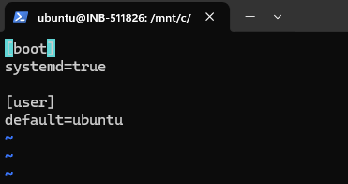
Now close the powershell and start again
Give cmd: wsl
ubuntu@INB-511826:/mnt/c/Users/pawan.kumar$
Shared path with windows and ubuntu for files exchange:
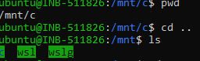
To exit/logout ubuntu/root :
ubuntu@INB-511826:~/.ssh$ exit
logout
Note – username = ubuntu, password = ubuntu

6. Generate SSH Keys
cd ~
ssh-keygen -t ed25519 -C "your_email@example.com"
cat ~/.ssh/id_ed25519.pub
- Copy the output and add it to GitLab (User Settings > SSH Keys).

7. Copy Tenant - Optional
The tar file contains a small tenant – 3582. This is fine for basic development. However, you can find and copy your favorite tenant with these steps.
To copy tenant, first select a tenant id that matches the development code branch and find its id # and cluster name
- cd .. (PycharmProjects/erc)
- python manage.py copy_tenant –cluster stable 1234
Update this tenant’s domain_domain entry via psql from wsl shell, replace 1234 below with your tenant id:
psql –U postgres
<enter password>
\c toogo_pos
SELECT * FROM domain_domain;
UPDATE domain_domain SET domain=’t1234.local’ WHERE id=1;
SELECT * FROM domain_domain; (to validate the update)
\q (to quit)
Method 2:
- cd .. (PycharmProjects/erc)
- Rebase
- python tools/setupPropelloRunConfig.py
- Enter choice 6(copy tenant) [Input: 1) cluster_name 2) tenant name 3) tenant ID]
- This tool will copy the tenant, verify the dump and create a migration configuration in PyCharm.
- Extra Note: If any permission issue you get then provide permission to the .idea folder [chmod -R <permission> </<Absolute path>/.idea/>]
- 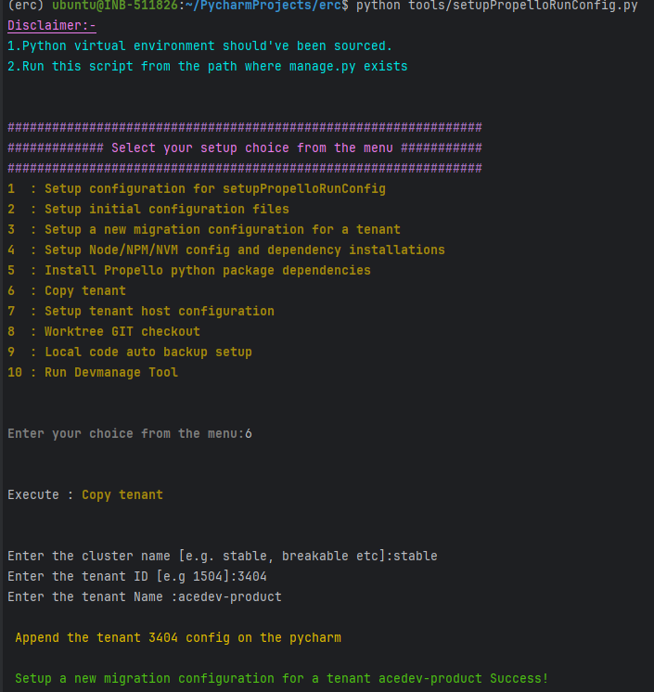
- 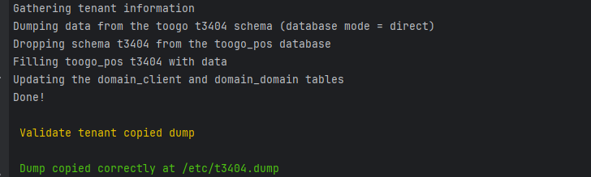

domain_client:
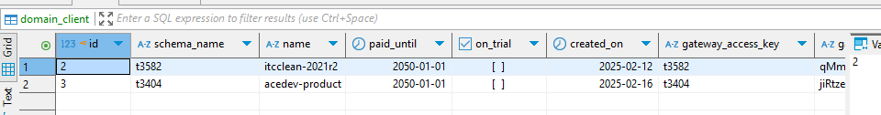
domain_domain:
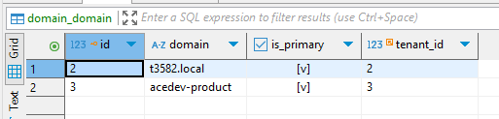

[DBeaver Setup]:
Open DBeaver after installing from here (For windows)
- Ctrl - Shift - N to make a new connection and select PostgreSQL
- Give below information:

Host: localhost
Database: toogo_pos
Port: 5432
Username: postgres
Password: postgres

- Now test connection. It should ask you to download some drivers. After downloading it should be working.
- Finish
After copy_tenant you should be able to see toogo_pos > public > Tables > [domain_client and domain_domain] for Edit/Verify.

8. Install PyCharm version 2024.2.5
- Install PyCharm on Windows
- License with your license key
- In PyCharm, turn off SSH forwarding in settings – File/settings/<search for SSH Agent Forwarding>, uncheck the box for “Enable SSH agent Forwarding”

9. Update Windows Hosts File with .local - Optional
Do this step if you did copy tenant above
- In Windows, update the hosts file, open Notepad as Admin, open hosts file in c:\Windows\System32\drivers\etc
- Add an entry with your copied tenant name, like t1234.local
- Example:
- localhost name resolution is handled within DNS itself.
127.0.0.1 localhost
127.0.0.1 t3582.local
- Be careful when saving file to use file type of “*.*” rather than text file so that file saves with no extension
Alternative:
- You can simply update the tenant's name which you just copied via setupPropelloRunConfig for e.g. acedev-product to the host file (c:\Windows\System32\drivers\etc\hosts) in admin mode after uncommenting the below two lines.
127.0.0.1 localhost acedev-product
::1 localhost acedev-product

OR
Simply run the below command to update the host file on windows
(erc) ubuntu@INB-511826:~/PycharmProjects/erc$echo ubuntu|psudo python tools/config_template/host_conf.py <Tenant Name>
Note:
- Add below line to ~/.bashrc
psudo() { sudo env PATH="$PATH" "$@"; } (Note: start using psudo instead of sudo)

10. Connect Browser to running PyCharm App
- In Windows, start PyCharm, select WSL option in sidebar
- Use dropdown to add existing project
- <any configuration settings here?>
- Browse to /home/ubuntu/PycharmProjects/erc and select it
- Pull code, migrate tenant, NPM build, run deferred server and either uvicorn server or gunicorn server
- In Windows, run browser as http://t1234.local:8000/#/login using your tenant ID in place of 1234
Or
Simply run: http://acedev-product:8000/#/login

11. How to Activate Environment
Activate the erc environment:
- cd ~/PycharmProjects/erc/
- pyenv activate erc
Or
Setup python virtual environment via PyCharm:
- Go to pycharm settings > Project:erc > Python interpreter > add interpreter > Add local interpreter > choose location as <~/.pyenv/versions/erc> > OK

12. How to Create Additional Code Branch Environments
Alternate Method to work on multiple GIT repo using GIT worktree:
- cd ~/PycharmProjects/erc/
- python tools/setupPropelloRunConfig.py
- Enter choice 8(Worktree GIT checkout)
- Enter the GIT branch name:release_candidate
- 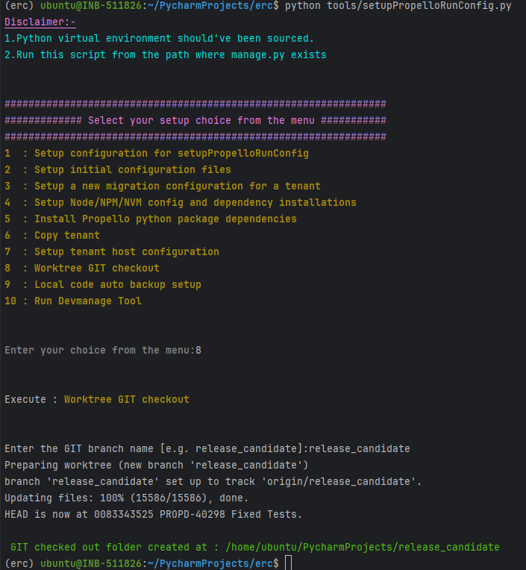
- Now open this new GIT repo in new PyCharm window.
- Create Python virtual environment. Go to pycharm settings > Project:erc > Python interpreter > add interpreter > Add local interpreter > choose location as <~/.pyenv/versions/release_candidate> >
- Install Python dependencies.
- Install NPM dependencies
Run: (erc) ubuntu@INB-511826:~/PycharmProjects/erc$ nvm install 22.10.0 && nvm use 22.10.0 && npm install -g npm && npm rm --global gulp && npm install --global gulp-cli && cd client && npm install

- Copy tenant
- Update .idea/runConfiguration with the configurations.

13. Nice to Haves – Optional
Edit ~/.bashrc to update the postgres password
Edit ~/.bashrc to add aliases like:
- alias enverc='cd ~/PycharmProjects/erc/; pyenv activate erc'
Edit ~/bin/gitme to use your name in NAME variable
Take note of ~/bin scripts:
- gitme – shows your recent commits in activated environment
- gitwho abcd – shows recent commits for author “abcd” in activated environment
- To configure all the initial configurations in pycharm , run `python tools/setupPropelloRunConfig.py` and select choice (2).
- Add below line to ~/.bashrc
psudo() { sudo env PATH="$PATH" "$@"; } (Note: start using psudo instead of sudo)

14. Note About Oddities Encountered – Optional
Just a note about an oddity some found when trying to commit code within PyCharm.
- Some developers encountered an error trying to commit code via PyCharm - “Commit failed with error”
- View the details in the console and reported error is “ModuleNotFoundError: No module named ‘toogo’”
- This relates to the erc/.git/hooks/pre-commit file created by migrate tenant and other runserver workers
- A possible fix is to edit this pre-commit file to include the following right before the line to “if [ -f tools/code_checks/erc_pre_commit.py ]; then”:
# Set PYTHONPATH explicitly
export PYTHONPATH="/home/ubuntu/PyCharmProjects/erc/site:$PYTHONPATH"
- Note that if this file does not exist, run migrate tenant or some other runserver task to create it

15. Make a WSL Backup via Export – Optional
To save your environment, make a backup of your WSL setup via the WSL export function
- Shutdown WSL – in Windows shell, run “wsl --shutdown”
- Export WSL to tar file -- In Windows shell, run “wsl –export Ubuntu-24.04 c:\SAVEMYENV\myenv1.tar

16. View How to Reference – Optional
View the WSL How to Tips document and update this with tips that will help all developers
- Link to Teams: WSL How To Tips.docx

